Technical Test- Part 1
Question (1.1): Identify the relationships between each table.
Answer (1.1):
- Each Geographic Location may have multiable Sales Person. (One-To-Many Relationship)
- Each Geographic Location may have multiable Customer. (One-To-Many Relationship)
- Each Customer may have multiable Order. (One-To-Many Relationship)
- Each Sales Person may submit multiple orders. (One-To-Many Relationship)
- Each Product can be ordered by Different Orders. (One-To- Many Relationship)
Assumptions:
It is production DB and we will have new data inserted later then we are going to do only minor changes to the existing schema, Solution without changing affecting the application Layer.
- Each Geographic Location may have multiable Sales Person. (One-To-Many Relationship)
Problem: - we have country names not unified i.e. (‘US’, ‘U.S.A.’) we need to Create Country Code to unify Data.
Solution: -
a) Add new Table Country (ID, CountryCode, CountryName)
b) Create function take country name and return Country Code.
c) Add Column “CountryCode” to the SalesPersons Table.
d) Add Column “CountryCode” to the GeographicLocation.
e) Add after Insert Trigger to Fill the Country Code Using the created Function.
Note: - script for this solution included in the SQL Script file attached with this document.
- Each Geographic Location may have multiable Customer. (One-To-Many Relationship)
Problem: - we have City Column that include city name which may repeated in different countries. If we create foreign key between city in Customers and city in Geographiclocation Table, then we need to create unique constraint on City Column in GeographicaLocation Table, which means we can’t insert new City with the same name but in different country in the GeographicaLocation.

Solution: - To solve this we need to change the Application Layer to add the missing information about which Country the Customer’s City is.

- Each Customer may have multiable Order. (One-To-Many Relationship)

Problem: - Some orders have Customers IDs not existing in the Customers Table like CustomerID “75353” have order entry but missing from customer table.
Solution: -
- Create instead of Insert Trigger on orders to insert customerID in Customers Table if not Exists with a Dummy company name like “Company1”, “City1”.
- Create foreign key on CustomerID in Customers Table references CustomersID on orders.
Note: - SQL script for this attached with this document

- Each Sales Person may submit multiple orders. (One-To-Many Relationship)
Problem: - N/A
Solution: - Create foreign key on PersonID in SalesPersons Table references PersonID in Orders Table.
Note: - SQL script for this attached with this document

- Each Product can be ordered by Different Orders. (One-To- Many Relationship)
Problem: - N/A
Solution: - Create foreign key on ProductID in Products Table references ProductID in Orders Table.
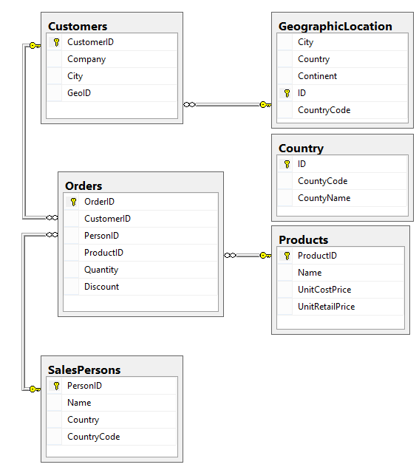
Question (1.2): write a query that shows the total sales amount by each sales person for each product.
Answer (1.2): Note: - SQL script for this attached with this document 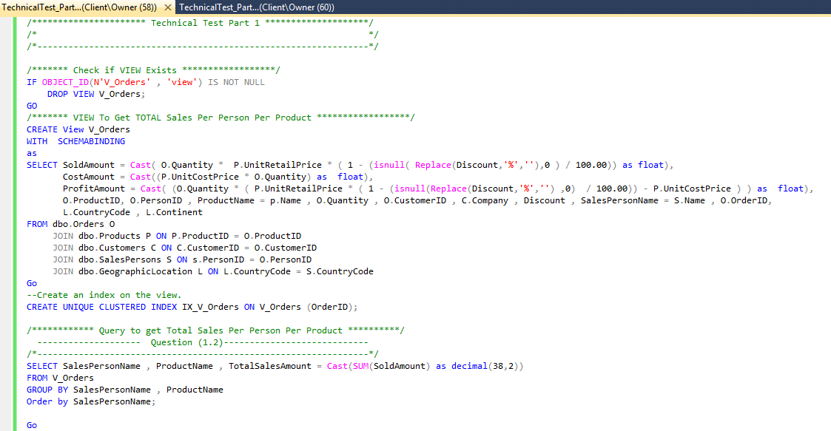
Question (1.3): Show All the products ordered by IBM, including number of units and total sold amount.
Answer (1.3):
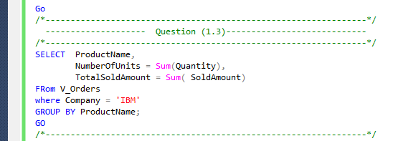

Question (1.4): shows the total profit amount and percentage made on all the sales of Charts by Continent, Country and Sales person including number of units, total cost amount and total sold amount.
Answer (1.4):
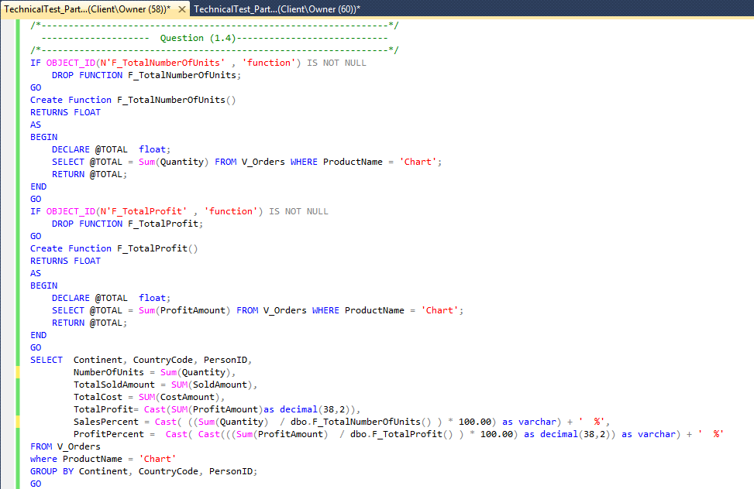
Question (1.5): describe at least 3 recommendations for the application database manager or to the sales manager regarding
Answer (1.5):
Recommendations for the application database manager:
- It is better to Name Tables with Singular Nouns.
- Tables Schema & Missing Data Integrity
- Product Table :
  - Should include primary key on ProductID.
  - Name column Size is small only 50 characters.
- SalesPerson Table:
  - Should include primary key on PersonID.
  - Name Coulmn Size is small only 50 characters.
  - Country column contains the name of the contry which is not unique as (‘US’ , ‘U.S.A.’ ) this Coulmn must be replace by CountryCode.
- Customers Table:
  - Should include primary key on CustomerID.
  - Name Coulmn Size is small only 50 characters.
  - City column must be replace by CityCode.
- GeographicaLocation Table:
  - Divied this table into two tables (City & Country ).
- Orders Table:
  - Discount Column DataType need to chang into double. It is now char(5) which even can’t accept ’99.99%’
  - There is no verification rule on the discount
  - Create primary Key On (OrderID).
  - Create Foreign key on ProductID references Products(ProductID).
  - Create Foreign key on PersonID references SalesPerson (PersonID).
  - Create Foreign key on CustomerID references Customer(CustomerID).

- Shortage in current Schema : each Order must contain only one product. You can add new Table for Order Details.
- Add OrderDateTime to Order Table, it Will make it easy for you to do your profit and sales on specific Time Frame.
Recommendations for the Sales manager:
- Insert Customer Data before inserting the Order.
- Insert Discount amount without the ‘%’ Sign.

